KentSoft Code of conduct 

**Be inclusive**KentSoft welcomes people from all backgrounds and ethnicities. This includes but is not limited to members of any gender identity, race, ethnicity, culture, economic class, colour or religion.

**Be considerate**  
At KentSoft, we all depend on each other to produce the best work we can as a company. Your decisions will affect our clients, and you should take those consequences into consideration when making any decision.

**Be respectful**As a team we won't always agree all the time, but disagreement is no excuse for disrespectful behavior. We will all experience frustration from time to time whilst working on projects, but we cannot allow this to affect our work or working environment, as this will affect the team’s productivity.

**Exit Clause**

This will be the steps taken for a team member complete the process of leaving. The leaving member will have to do the following:

* Give up access to the GitLab repository
* Give up access to the Trello Board
* Give up access to the KentSoft Group Chat

The leaving member will be forced to sign an NDA to protect client interests, concerning any projects they were working on.

**Signature**: *Adil Jawad* **Signature**: *Tsotne Gvadzabia*

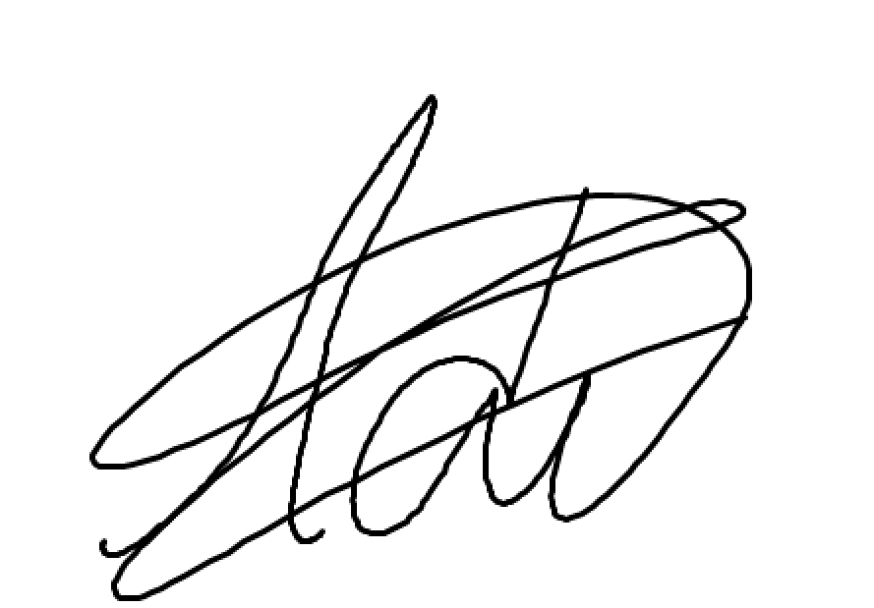 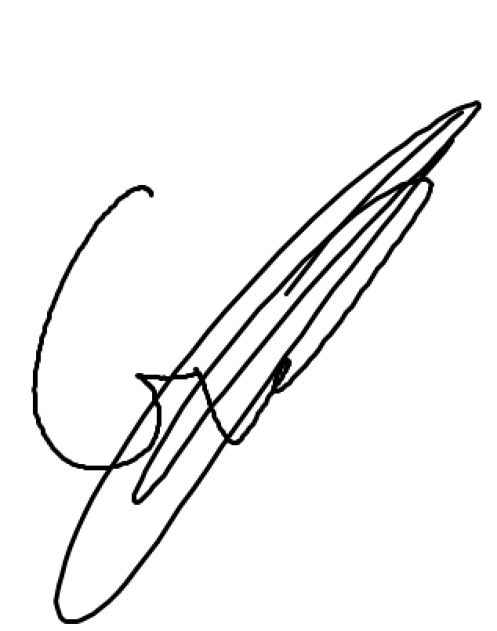

**Signature**: *Rahul Patel* **Signature**: Samuel Ling

